Feasibility of eliminating and replacing single-use products in Hotel industry

Prepared for American Hotel and Lodging Association (AHLA)

Table of Contents
Summary..........................................................................................................................................3
Introduction..................................................................................................................................4-5
Overview..............................................................................................................................4
Effects…...........................................................................................................................4-5
Benefits................................................................................................................................5
Key Problems...................................................................................................................................6
Environmental issues...........................................................................................................6
Description...............................................................................................................6
Improvements..........................................................................................................6
Economic.............................................................................................................................7
Alternatives.............................................................................................................6
Cost........................................................................................................................6
Social..............................................................................................................................7-8
Education…..........................................................................................................7
Incentives…………………....................................................................................8
Benefits.......................................................................................................................................9-10
Positive Environmental Impact …......................................................................................9
Sustainable.........................................................................................................................10
Conclusion.....................................................................................................................................10
References......................................................................................................................................11
Appendix........................................................................................................................................12
Figures and Tables
Graph 1. Global Plastic Waste by Disposables
Graph 2. Global Plastic Production from1950 to 2015
Map 1. Plastic Impact on World’s Oceans
Summary
The purpose of this study is to determine the feasibility of installing a mandatory standard for hotel companies to limit the amount of single use products and plastics across the industry. These regulations will help the environmental crisis that these single use products are increasing. There are countless benefits that mandatory rules in hotels will help; starting from the reduction of plastic waste while supporting environmental friendly products. Standards enforced and controlled by the AHLA of the use of single-use products and plastics,will show staggering evidence to make the initiative a model for global hotel associations to follow. Since, the association inspires other Westen and Eastern countries to strive for. There were several distinctive initiatives by numerous global hotel companies to help control the production and consumption of plastics. These initiatives have been at the individual level of each company and certain locations of resorts that have an impact on the issue is not notable. Whereas the proposed mandated regulations will create a significant impact on the waste from the hotel industry. There have been many non-profit and small organizations that are available to recycle products like soap bars and creating alternatives for plastics in toiletries. The main purpose of this report is to determine the feasibility and reliability of the formation of required standards for hotels that would regulate the use of plastic single-use waste. In order to assess the feasibility of these rules, it needs to fulfill these terms: capability of hotel companies following, access to alternative and eco-friendly products, and financial soundness. The research suggests that the enforcement from AHLA to regulate the usage of plastics products is . It is clear that even though the AHLA only has jurisdiction over hotel companies that are members, if members follow and uphold the guidelines there will be a significant impact on the industry standards and in turn on the environmental plastic crisis. More countries would take the opportunity and responsibility of providing waste management techniques to the world
Introduction
Overview
The following is a proposal of a feasibility report for how the hotel industry creates crucial guidelines of replacements of single-use products that hotels must follow as well as an incentive for companies that exceed standards with awards and marketing promotions. This proposal will create not only new environmental standards for hotels of all venues but make a path for a cleaner future. Exploring the problem with specific criteria that must be answered and followed before the proposed solution can be completed will be explained in the feasibility. In the following sections the need and benefits for the report as well as an outline, schedule, and associated costs will all be addressed in the feasibility report.

Single-Use and Plastic Waste
These are plastics that are made and are supposed to be used once and dumped. A good example is using a straw to sip iced tea and later on dumping both containers. These plastics are very dangerous to the environment as they are used in high quantities due to their contingency. These waste released in our environment equals the amount of plastics produced. Most hotels offer these as a convenient mode for their clients. These plastics can be easily recycled and turned into some important gadgets like polyester fabrics or even automotive parts. But this is not the case most of the times. These plastics when not recycled they can turn result in our rivers and water bodies after being exposed to sunlight and turned into micro plastics.

Benefits
Many significant benefits can come from the proposed feasibility report. Hotel plastic use is beneficial because they impact the effects of global plastic intake; providing disposable products at mass scope. First, the report will cover in-depth research on incentives and alternatives associated with replacing plastics as well as cost points. This data will mainly come from articles recently put out by G.R.E.E.N Hospitality, Hospitality Insights, as well as TUI Group that offer a crucial look at how this proposal could impact by providing Plastic reduction guidelines for hotels. Next, it can put quantitative data by tracking the population of plastic waste and how many hotels could put new standards in place

Key Problems
Environmental Issues
Description and Improvements
The rising rate of pollution especially of plastic, is one of concern. A study shows how moving towards a sustainable future slowly in industries that within the next 10 years we will see a major decrease in pollution and increase in global wellbeing. Mandating standards of replacing single-use plastics in the hotel industry may be economically costly at first but will pay off with being sustainable in the long term, and improve occupancies as the public shifts toward eco-conscious tourism. Eliminating plastic and single-use waste in hotels will be a major step to move towards a new start to get our planet back on track.
Economic

There are several financial factors that go into removing plastics and single-use waste from hotels in the US and globally. There are three main financial points to focus on. The first being sustainable product replacements. Plastics are cheap but renewables can be more expensive. The price mainly depends on the____. If the American Hotel and Lodging Association (AHLA) is willing to enforce new guidelines of no plastic or single-use waste like soaps and cups then other countries' hotels and lodging will follow. Another financial factor is the sustainability of the guidelines. There is need to have proper measures that would ensure that all the hotels are capable to sustain these guidelines in terms of financial implications. The other factor is looking at whether the world is ready for the new guideline and the government willingness to encourage implementation. The government on its part must be willing and ready to lose the revenue that came from plastics and even subsidize the new measures of no plastic and use of water and soap as alternative.
Social
Plastics can cause a threat to human life when improperly disposed. Sharp objects that are left lying on the fields can cause serious injuries in the body. Most hotels use plastics to reserve their foods and sell them. These foods are heated in a microwave which emits energy that is used to heat the food that causes cancer after a prolonged use. Hotels should instill regulations to reduce the amount of plastics that are used in their premises. They should educate their workers on the right products to order. They should work with community to eradicate some of the traditional beliefs of recycling and adopt new ways in the hotels and the community. This cannot be done without proper monitoring and support from the local government.

Figure 1., Below, displays the
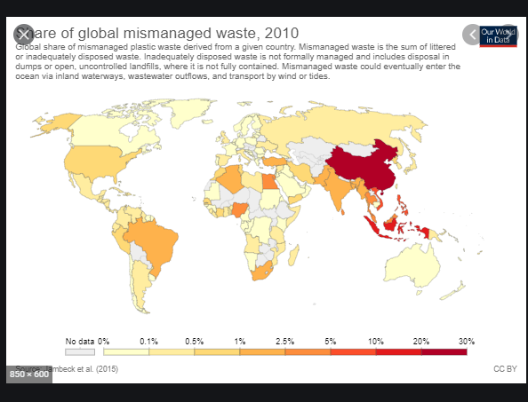
(Figure 1.)

Benefits
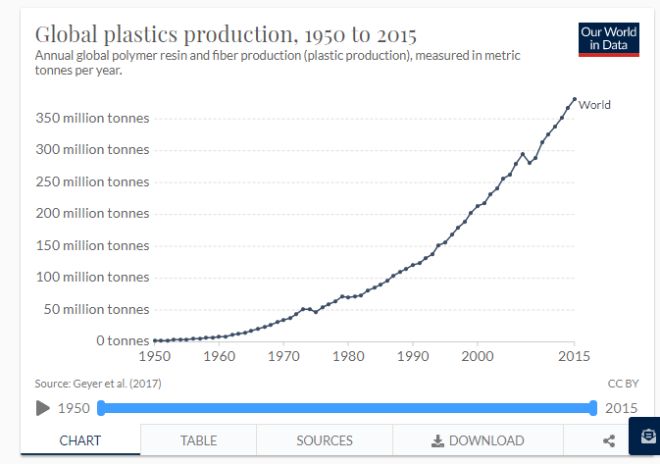
(Figure 2.)

Positive Environmental Impacts
Removing plastics from our environment will greatly impact on our ecosystem. One marine life will be improved. This is because a lot of fish die due to the plastics dumped along the beach that end up in the ocean. It will also boost tourism as many species of fish will now survive on the environment. It will also reduce greenhouse gas emissions into our environment that alters our ecosystem like rain. Using PET bottles helps to save energy as compared to the use of normal plastic bottles which results in a lot of energy consumption. PET bottle can decay over a period of time and can be easily recycled.

Sustainable
Hotels are part of the sector that contributes to a lot of waste in the environment. Tourists who visit these hotels want pleasure, some of those who do hiking want to carry their water and leave the bottles lying everywhere. They can however reduce the amount of waste released on our environment if they undertook simple measures. To begin with, they should generate a waste register in the hotel. This can be done by a proper list circulated every day on the number of plastic products found in the room and how many of those are used and disposed of. They should make sure that single-use packaging merchandise are not used. They should recyclable products like spoons, cups, and skincare products.
They should pack their take away food in boxes instead of plastics and give returnable vessels. Most people will prefer plastics to boxes as they are durable and can be stored for a long time but with the right information from the staff, they should be able to convince their clients why they need boxes instead of plastics.This will help to reduce the number of plastics distributed. They should insist on the benefits of tapped water instead of bottled water for their tourists and guests.
Staff should be regularly trained on the ways of recycling waste whenever possible. This is key because they are the first people to interact with the guests and can give alternatives to see recycling waste if better managed. The hotel management should work in partnership with other stakeholders to see that these initiatives are put in place. They should also work with manufacturers and give directives that non-reusable products will not be accepted on their premises.

Conclusion
This proposal gave a brief explanation of the hotel industry's increasing epidemic of single-use waste and proved the need for the new and enforced guidelines to help solve this problem. The benefits will be reaped for generations to come.
References
1.Davis, Ben. “Plastic: What Can the Hospitality Industry Do to Tackle the Problem of Plastic Waste?” GREEN Hospitality, 17 Apr. 2019, https://www.greenhospitality.io/post/plastic-what-can-the-hospitality-industry-do-to-tackle-the-problem-of-plastic-waste
2.higginho. “The Rise of Sustainable Tourism.” GREEN Hospitality, 4 Oct. 2019, https://www.greenhospitality.io/post/the-rise-of-sustainable-tourism .
3.https://www.tuigroup.com/damfiles/default/downloads/plastic_reduction_guide.pdf-2f4f4f0e2278382fcd50d9a530985b84.pdf
4. The plastic problem: Phasing out single-use toiletries in hotels. (2020, March 13). Hotelmanagement. https://www.hotelmanagement-network.com/features/single-use-plastic-toiletries-hotels/
5. Martin, G. (n.d.). California bans single-use plastics in hotel rooms. Forbes. Retrieved July 13, 2020, from https://www.forbes.com/sites/grantmartin/2019/10/13/california-bans-single-use-plastics-in-hotel-rooms/
6. Going plastic-free: Hotels and airlines reducing plastic use. (n.d.). Retrieved July 10, 2020, from https://hospitalityinsights.ehl.edu/hotels-single-use-plastics-ban
7. The hospitality industry is at the forefront of tackling the excessive use of plastic and technology could pitch with a few alternatives. (n.d.). HotelierIndia. Retrieved July 13, 2020, from https://www.hotelierindia.com/business/8596-the-hospitality-industry-is-at-the-forefront-of-tackling-the-excessive-use-of-plastic-and-technology-could-pitch
8. (2020). Who We Are. Retrieved August 02, 2020, from https://www.ahla.com/who-we-are

Appendix
Figure 1- Global Plastic Waste by Disposal . Map
Figure 2 -Global Plastic Production from 1950 to 2015 Graph
Plastic Impact on World's Oceans Map
